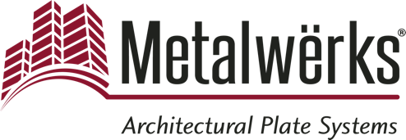

FOR IMMEDIATE RELEASE
Contact: Jeff Donaldson, BLD Marketing
Phone: 412-347-8039 E-mail: jeff.donaldson@bld-marketing.com
Date: June 17, 2020

Metalwërks® Secures Design Patent for Sculpted™ 3D Ribbon Panel
Three-dimensional rainscreen wall system, architectural feature recognized for innovation

KENNETT SQUARE, PA…Metalwërks®, a leading U.S. manufacturer of precision, high-performance metal plate exterior facade systems, integrated curtain wall components, and custom architectural features, recently secured a design patent for its Sculpted™ 3D Ribbon rainscreen system.

The company received the designation because of Sculpted 3D Ribbon’s visual appeal and its ability to serve as a canvas for eco-friendly planters and integrated lighting features. Simultaneously, the system is a high-performance rainscreen facade that operates as the building’s main weather protection barrier.

“When we first conceived of Sculpted 3D Ribbon, we firmly believed we had arrived at a groundbreaking solution that could help transform a building’s exterior in ways not considered before. The patent confirms this,” said Steve Scharr, director of business development at Metalwërks. “With Sculpted 3D Ribbon, architects and designers can integrate greenery and lights directly into a rainscreen system for the building’s facade, creating true stopping power for the exterior while also maintaining a unified look. At the same time, others may choose to include Sculpted 3D Ribbon in their project solely because of its interesting geometric patterns.”

Sculpted 3D Ribbon features a series of troughs and access holes within its hollow spaces. Visually, these channels provide an intriguing basket weave pattern while functionally allowing for plant irrigation or electrical connections.

In addition, Sculpted 3D is a turnkey solution with “plug-and-play” components that can be delivered to mechanical, electrical, plumbing, and landscaping trades in a pre-engineered assembly.

“Most projects using these types of wall features require bolting components onto the wall, leaving project teams to deal with coordination of the trades and wall penetration issues later,” added Scharr. “With Sculpted 3D, the features are already embedded within the system, eliminating additional coordination in the field and costly leaks.”

Sculpted 3D is available in three separate design schemes: Ribbon, Parametric, and Minimal. The solution can be made of aluminum, stainless steel, or zinc and manufactured in sizes ranging from 24- to 48-inch widths and 48- to 160-inch lengths. The system’s depth measurements vary.

For more information of Metalwërks Sculpted 3D, visit www.metalwerksusa.com/product/sculpted-3d/

About Metalwërks

Metalwërks is the leading U.S. manufacturer of precision, high-performance metal plate exterior facade systems, integrated curtain wall components, and custom architectural features. Founded in 1968, the company operates as Metal Sales & Service, Inc. Metalwërks is Headquartered in Kennett Square, Pa. and has production facilities in Elkton, Md. For more information, visit www.metalwerksusa.com.

# # #

